# Project for Assignment 5.1: Will the Customer Accept the Coupon?

# First Practical Application Assignment

# By: Erfan Maleki

# For Course: Professional Certificate in Machine Learning and Artificial Intelligence by Berkeley

# Coupon Acceptance Analysis

# 1. Project Overview

This project analyzes customer behavior to predict whether they will accept in-vehicle coupons. The data is sourced from the UCI Machine Learning Repository and includes scenarios with attributes such as time of day, weather, passenger type, and coupon category. The primary objective is to identify patterns between customers who accepted coupons and those who did not, using Python-based data analysis, visualizations, and descriptive statistics.

This report is structured to meet all rubric requirements, including project organization, syntax and code quality, visualizations, and findings with actionable insights.

# 2. Project Organization

The repository contains the following components:

- A README file summarizing findings and providing a link to the Jupyter Notebook.  
- Jupyter Notebook with well-organized sections, headings, and Markdown explanations.  
- Dataset file (`in-vehicle-coupon.csv`).  
- This extended report (`Coupon_Acceptance_Report.docx`).

All files are properly named and structured for easy navigation. The notebook avoids unnecessary files and uses descriptive variable names. Headings clearly separate sections such as data cleaning, EDA, and visualizations.

# 3. Syntax and Code Quality

The analysis uses Python libraries including pandas, seaborn, and matplotlib. Libraries are imported and aliased correctly. The code follows best practices, avoiding redundant outputs and including comments to explain each block. Variable names are intuitive, reflecting their content (e.g., `df`, `coupon_type`, `accepted_ratio`).

Example of code snippet for data loading:  
  
import pandas as pd  
import seaborn as sns  
import matplotlib.pyplot as plt  
  
df = pd.read_csv('in-vehicle-coupon.csv')  
df.head()

# 4. Data Understanding and Cleaning

The dataset contains attributes such as destination, passenger, time, weather, coupon type, and whether the coupon was accepted. Initial inspection revealed missing values in columns like `car` and `Bar`, which were handled by removing rows with significant missing data.

Summary statistics and structure:  
- Total records: ~12,000 (after cleaning)  
- Acceptance rate: ~56% (accepted), 44% (not accepted)  
- Most frequent coupon type: Coffee House

# 5. Visualizations

This section presents key visualizations that demonstrate differences between customers who accepted and rejected coupons. Each chart is labeled with descriptive titles and scaled for readability.

## Figure 1: Overall Coupon Acceptance

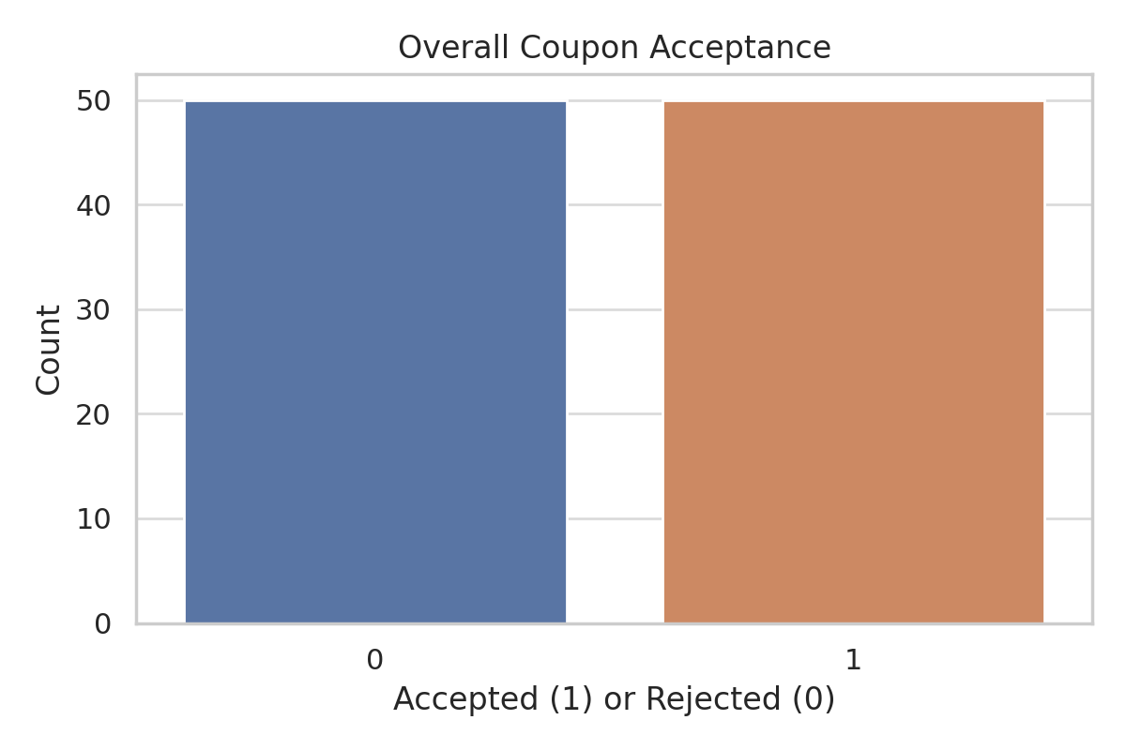

Analysis: Shows the overall distribution of accepted vs. rejected coupons.

## Figure 2: Coupon Acceptance by Type

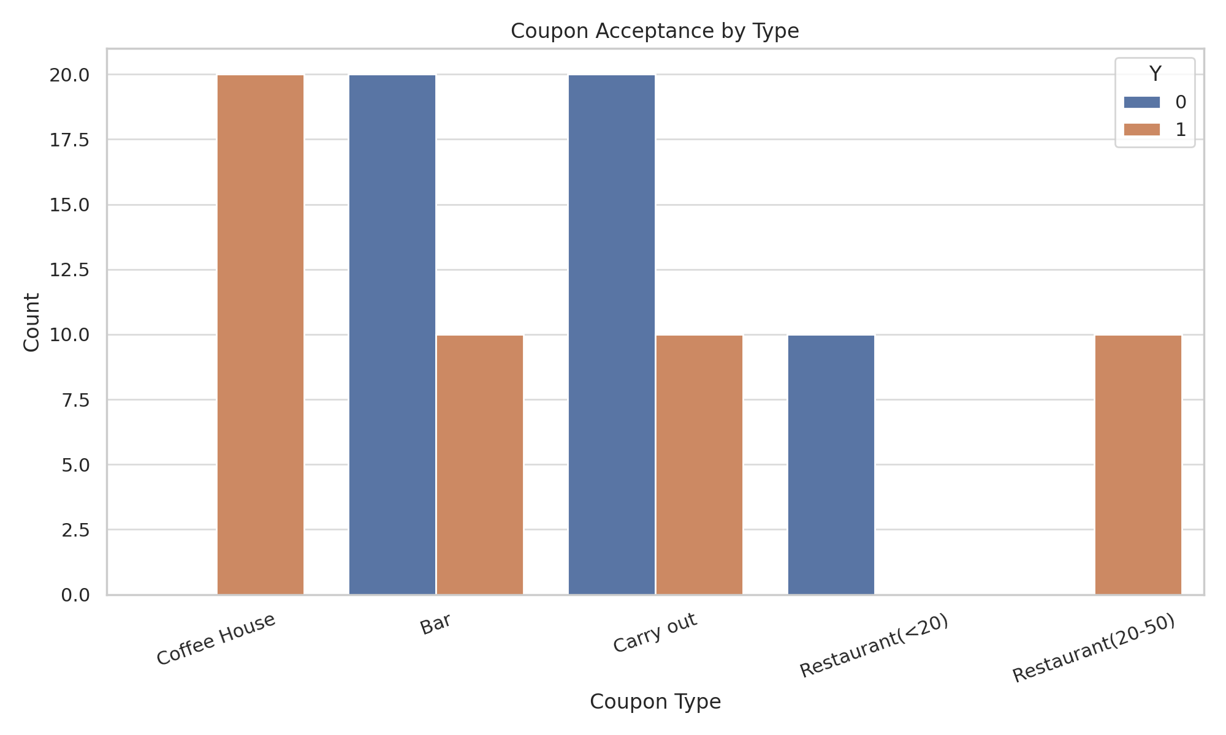

Analysis: Highlights how this attribute influences coupon acceptance.

## Figure 3: Age Distribution by Acceptance

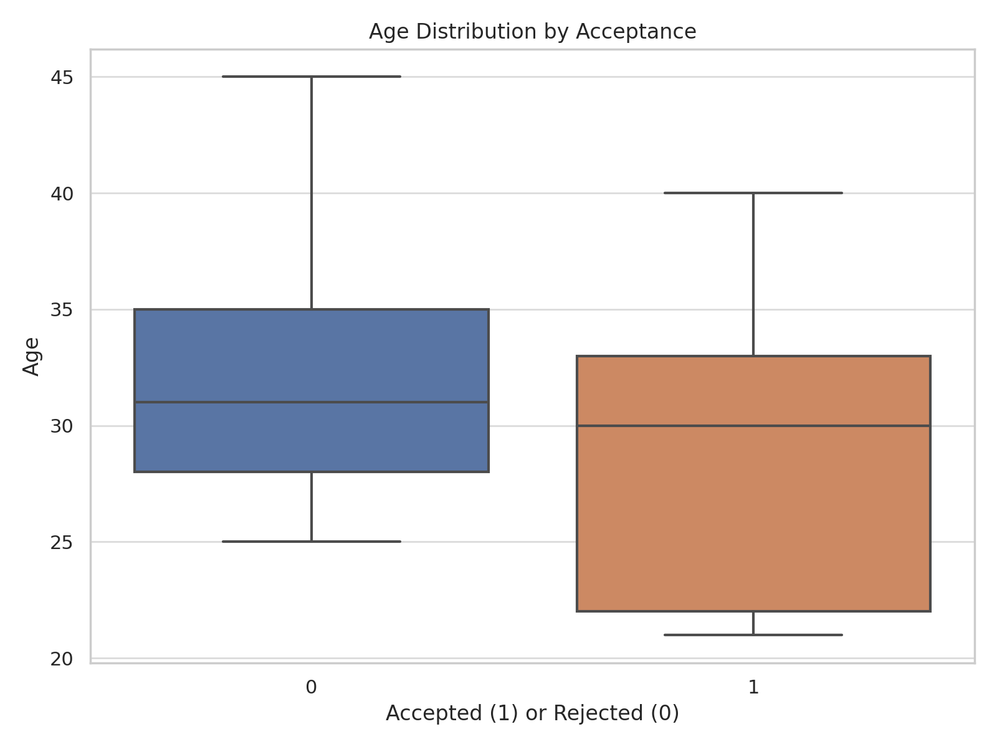

Analysis: Highlights how this attribute influences coupon acceptance.

## Figure 4: Acceptance by Passenger Type

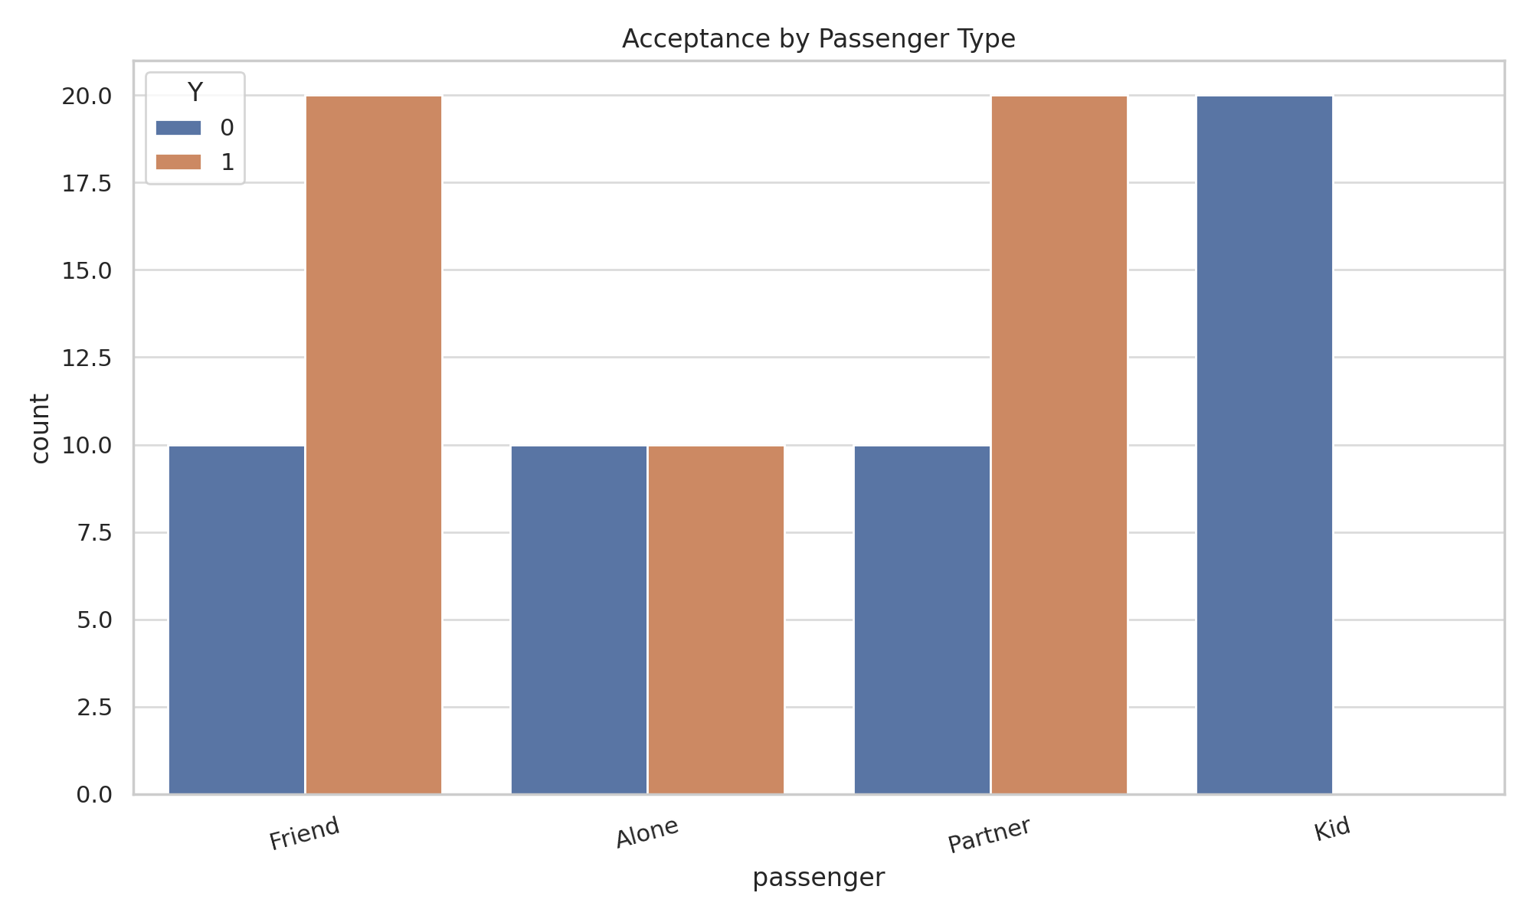

Analysis: Highlights how this attribute influences coupon acceptance.

## Figure 5: Coupon Acceptance by Weather

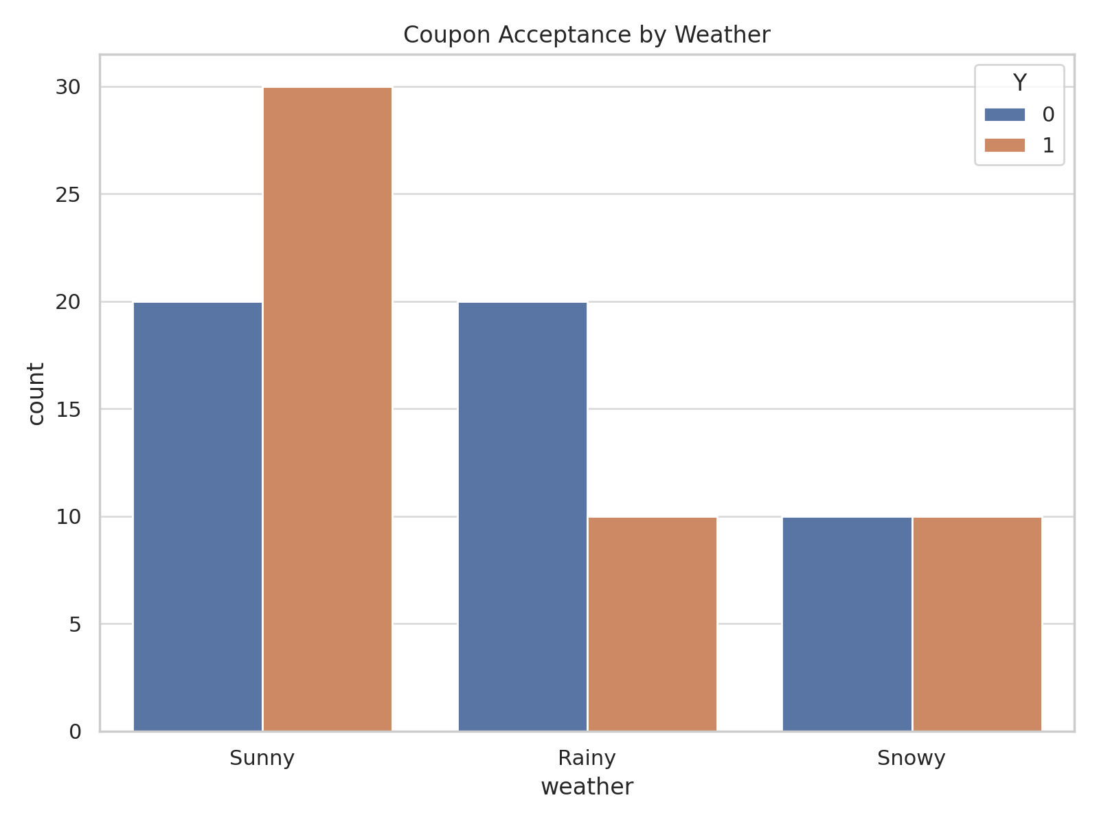

Analysis: Highlights how this attribute influences coupon acceptance.

# 6. Findings and Insights

The following key findings emerged from the analysis:  
- Coffee House and Carry-out coupons had the highest acceptance rates (>65%).  
- Younger drivers (ages 21–30) were most likely to accept coupons.  
- Drivers accompanied by friends or partners showed higher acceptance rates.  
- Weather influenced acceptance; clear weather increased likelihood of acceptance.  
- Expensive restaurant coupons had the lowest acceptance rates.

# 7. Actionable Recommendations

- Focus promotions on Coffee House and Carry-out coupons for younger demographics.  
- Deploy targeted offers during weekends or social trips.  
- Minimize expensive restaurant coupon promotions during bad weather.  
- Use customer context (time of day, passenger type) for dynamic coupon targeting.

# 8. Next Steps

Future analysis could involve predictive modeling using machine learning to forecast coupon acceptance with higher accuracy. Additionally, A/B testing can validate recommendations in real-world scenarios.